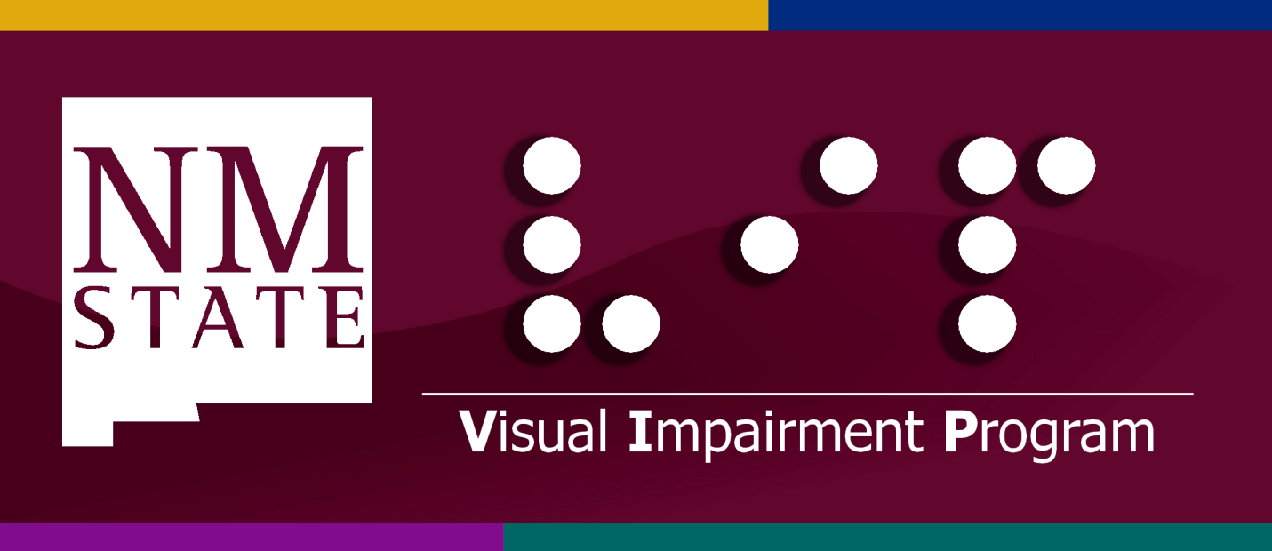
Preparing Highly-Qualified TSVIs and COMSs

APPLICATION PROCESS

The application process is now entirely online, and the application instructions are as follows:

- Go to http://prospective.nmsu.edu/graduate/apply/index.html to start the electronic application.

- On the application, select education as your major, special education as your concentration, and Master of Arts as your degree. Unfortunately, there is not a direct way to apply to the certification programs in the Visual Impairment Program (teaching students with visual impairments--TSVI or certified orientation and mobility specialist—COMS). Once you are admitted, your Program of Study will reflect which certification program(s) you are interested in and if you also want to pursue a master’s degree.

- The following documents are required for admittance into the Special Education and Communication Disorders Department and must be uploaded electronically: 1) Letter of Interest, 2) Academic Transcripts, 3) Reference Letters, 4) GRE Scores (not required for the Visual Impairment Program), and 5) Curriculum Vita. Go to http://prospective.nmsu.edu/graduate/degrees/edu/sped.html for more information about requirements.

  - Letter of Interest: This is basically a one page statement talking about your relevant background and why you want to pursue this field of study. In order to ensure that your file gets routed to the Visual Impairment Program, you need to make sure to indicate in your Letter of Interest that you want to be admitted into the Visual Impairment Program to pursue licensure in teaching students with visual impairments or certification in orientation and mobility.

  - Transcripts: You need unofficial transcripts from all the colleges or universities you have attended, and your cumulative GPA needs to be a 3.0. Once you are accepted into the program, the graduate school will require copies of your official transcripts. Official transcripts must be sent directly from all colleges/universities you have attended, and the graduate school must receive them before you are allowed to register for courses. (Note: For transcripts to be considered official, they must be sent from one registrar directly to another and can never have been in the hands of the student.)

  - Reference Letters: You need 3 reference letters from either professors or professionals. The online application includes forms that need to be filled out by your references. While a written letter is not required, it helps give us a better picture of who you are and what strengths you possess. If you choose to get written letters, make sure your references also fill out the required form. The online system asks you to input the e-mail addresses of your references, and it generates an automatic e-mail with the required form. You can include a personal message, and thus, you may want to give your references a date by which they need to submit their recommendations. You will need to check back with your references to make sure that they have submitted the necessary documentation online.

  - GRE Scores: Although these are not required for the Visual Impairment Program, the online application will ask you to upload your scores. If you have taken the GRE, by all means, upload your scores—so long as they are passing. If you have not taken and passed the GRE, report the following scores: Verbal—130, Quantitative Reasoning—130, and Analytical Writing—0. Use the application date as the date you took the GRE. If you submitted authentic scores, upload a copy of your official score report; otherwise you need to upload a blank document with a statement indicating that GRE scores are not required for the Visual Impairment Program.

  - Curriculum Vita: An academic and professional resume detailing your educational history, employment history, any professional publications you have done, any professional presentations you have done, etc. is required.

- If you are an international student for whom English is not your native language, you will need to submit scores for either the Test of English as a Foreign Language (TOEFL) or the International Language Testing System (ILTS). A passing score of either 550 on the paper version of the TOEFL, 79 on the internet version of the TOEFL, or 6.5 on the ILTS is required.

- Pay the application fee of $40.

Applications are due by March 15, at which time a selection committee will review completed applications, interview qualified candidates (either in person or from a distance), and make final admittance decisions by the middle of April. Due to the small size of our program, we are only able to admit 15 students into the TSVI program and 6 students into the COMS program each year. For additional information, please contact Dr. Loana Mason, Director of the Visual Impairment Program, at loanam@nmsu.edu or 575-646-5703.

Sincerely,

Loana Mason, Ed.D., COMS
College Assistant Professor
Director of the Visual Impairment Program
Department of Special Education and Communication Disorders
Speech Building, Room 248
loanam@nmsu.edu
575-646-5703

